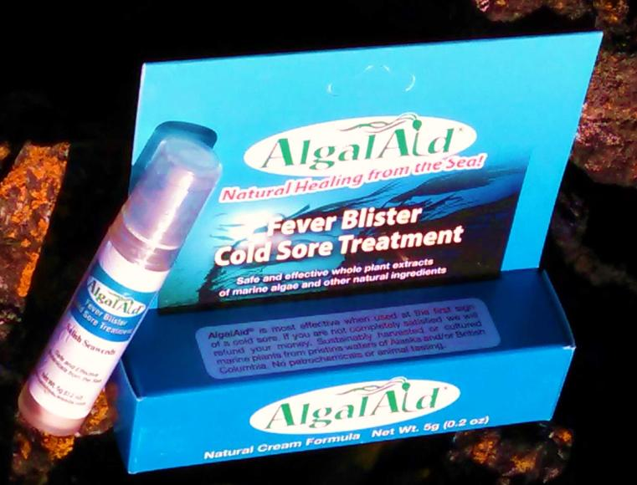

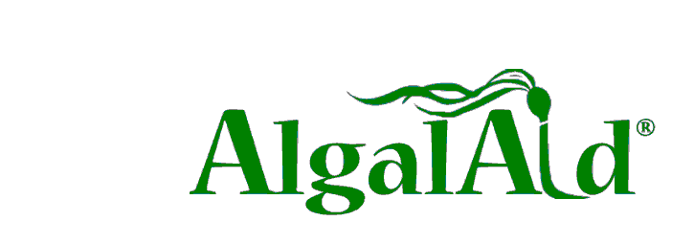

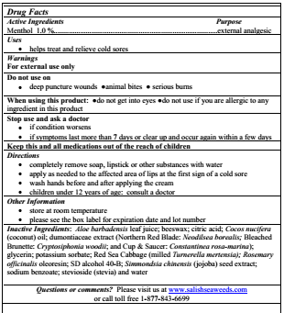
Salish Seaweeds proudly introduces AlgalAid®, an FDA monograph compliant external analgesic for the treatment of cold sores and fever blisters. Each lot contains whole plant extracts of marine red algae whose anti-viral efficacy is measured and incorporated in AlgalAid to provide ten times the concentration needed to inhibit 90% of HSV1 virus.

● 4 species of marine plants each possess thoroughly researched natural sulfated polysaccharides that interfere with the ability of HSV to adhere to the cell surface receptors of infected individuals.

● The whole plant extracts contain a suite of anti-herpetic compounds effective against a range of viral strains, including acyclovir resistant HSV.

● These plants have a demonstrated efficacy and safety record in over 30 years of use by compounding pharmacists and contain no petrochemicals.

● Salish Seaweeds will support each retail outlet with a launch program which includes targeted sample distribution, consumer education, staff training and opening order discounts.

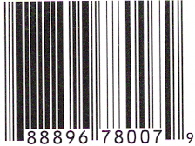 | Wholesale: $7.79  MSRP: $14.95

Salish Seaweeds
Safe, Effective Botanicals from the Sea
PO Box 4302 Friday Harbor, WA 98250
www.salishseaweeds.com
1-877-843-6699

